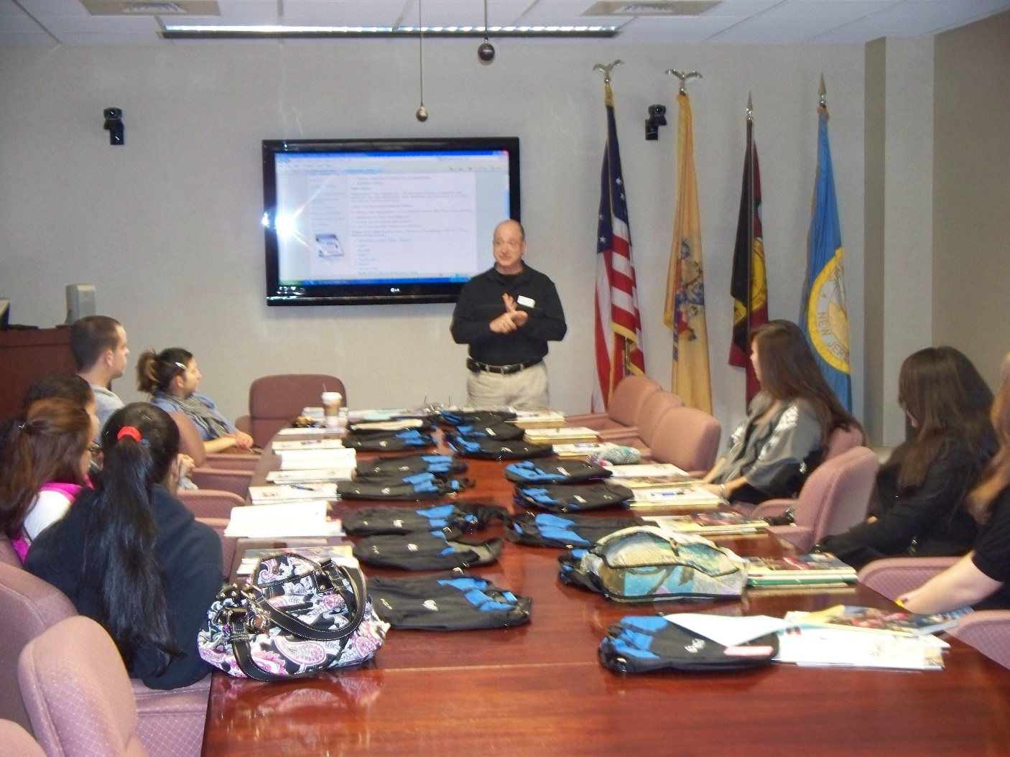

Fall 2017

Career Workshop for Mays Landing Campus
For more information about the workshops, please contact the Career Center at ext 5621 or you can email Cynthia Correa at ccorrea@atlantic.edu
Workshops will be held in the Career and Academic Planning Center (Advisement), J building, 1st floor lobby area.
Time: 12:30 p.m. to 1:30 p.m.
Career Workshops for Students with less than 24 credits.
September
Make Sure You Are in the Right Major? (Exploring Careers)
- Save time and money
- Being more successful and completing your degree
- Students who start early are more successful
Tuesday, September 19th, 2017 and Wednesday, September 27th, 2017.
Career Workshops for Students with More than 24 credits.
Are You Prepared for Life After Atlantic Cape?
- Are you going to work?
- Are you going to transfer?
- Here is what you need to do
Thursday, September 21st, 2017 and Monday, September 25th, 2017

